Linux Networking Hands-On

**Task 1: Basic Network Configuration**

1.1. Identify your current network configuration using ‘ifconfig’ command :

ifconfig
This command will display information about your network interfaces,IP addresses and related network configurations.

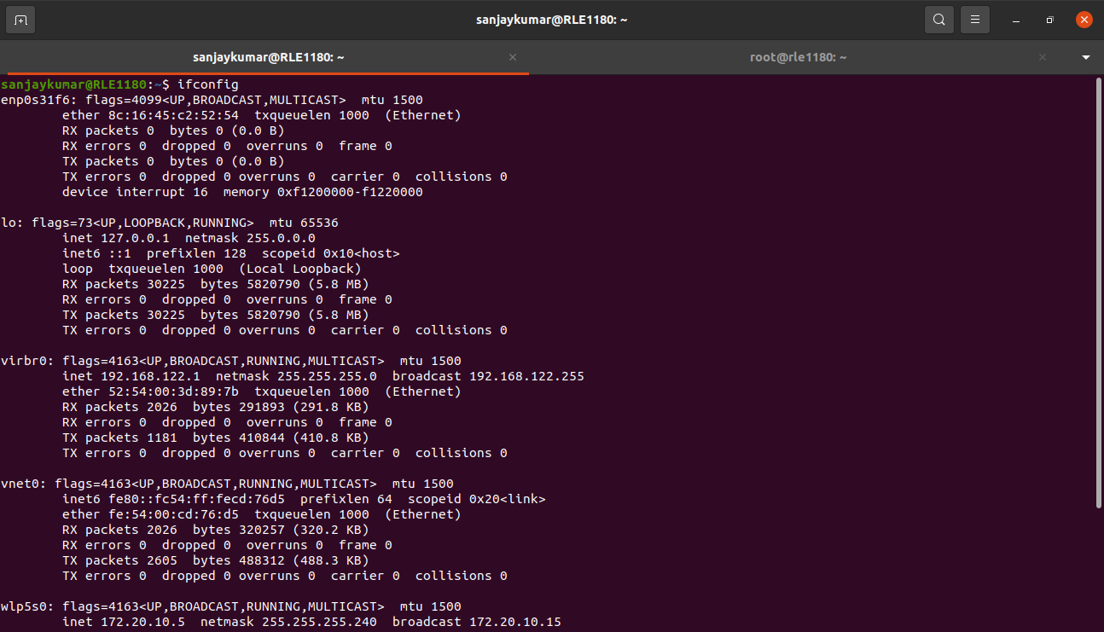
1.2. Change your system's hostname using the ‘hostnamectl’ command :

sudo hostnamectl set-hostname newlocalhost

1.3. Modify the /etc/hosts file to add an entry for your hostname.

sudo nano /etc/hosts
This command will open the /etc/hosts file in the nano text editor. Inside the /etc/hosts file, add :

127.0.0.1 localhost
127.0.0.1 newlocalhost
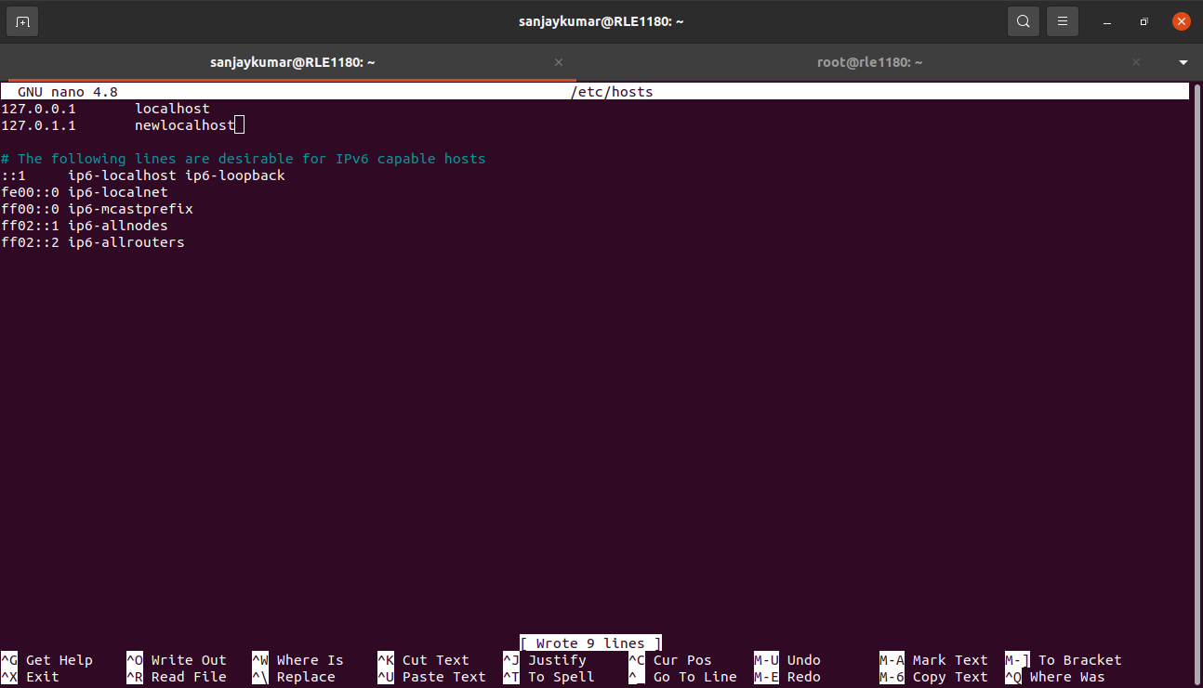

1.4. verify the changes.

To verify the changes use the following command :
hostnamectl
It will display information about the system, including the hostname.

To verify the /etc/hosts file :

cat /etc/hosts
This command will print the contents of the /etc/hosts file to the terminal, and you can verify that your hostname entry is correctly added.
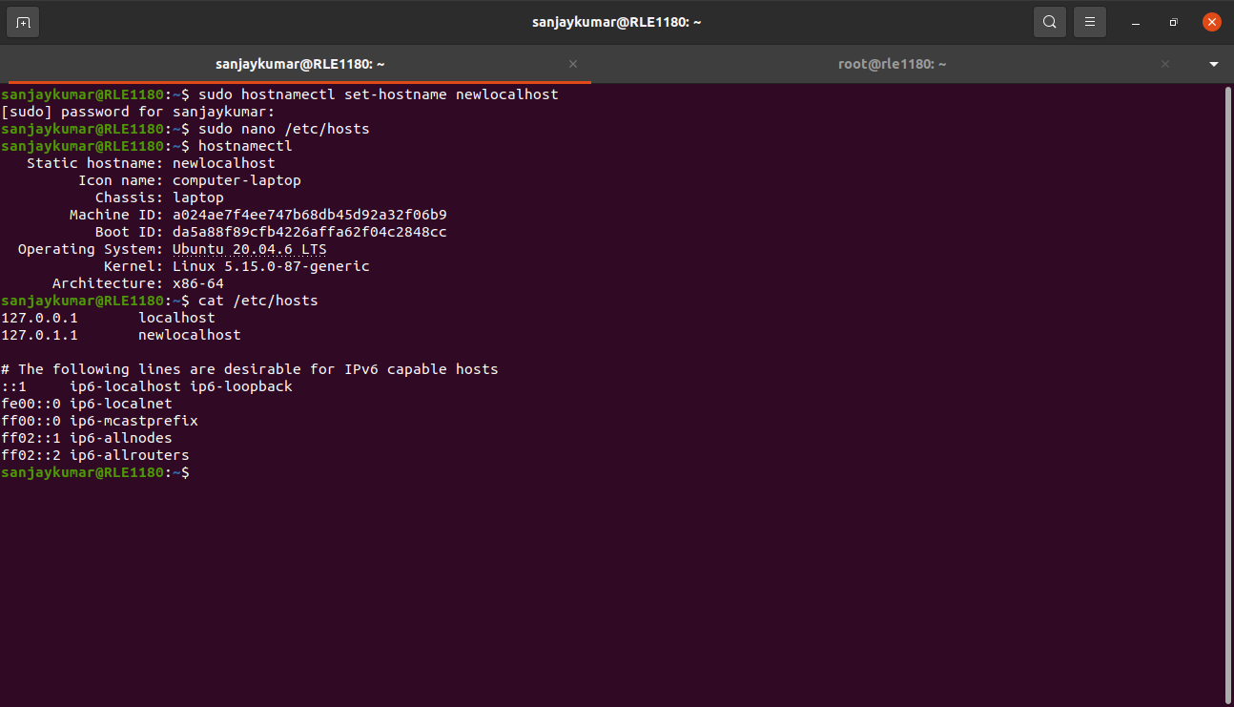
**Task 2: IP Address Configuration**

2.1. Configure a static IP address :

You can configure a static IP address by editing the /etc/network/interfaces file.

sudo nano /etc/network/interfaces
Inside the file, to set a static IP address for you system add the following content :

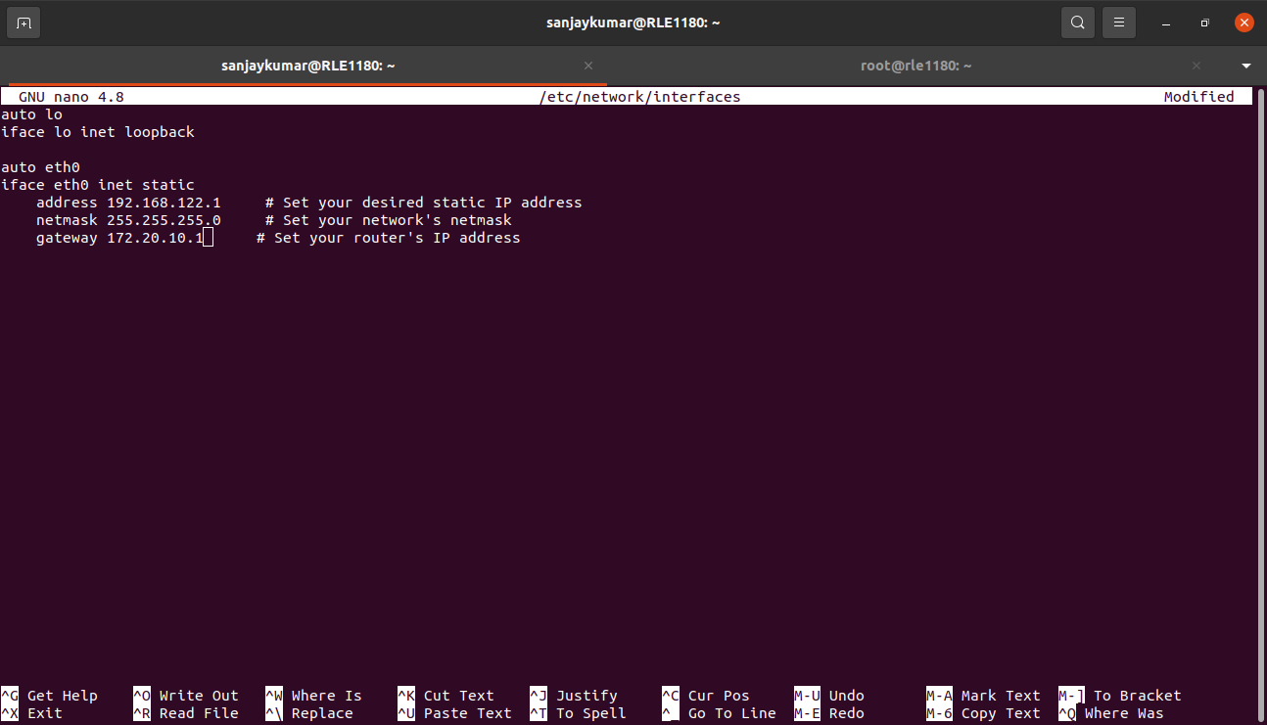
2.2. Restart the network service to apply the changes :

sudo systemctl restart networking
This will restart your network service with the new static IP configuration.

**Task 3: DNS Configuration**

3.1. Edit the /etc/resolv.conf file and add DNS server addresses :

sudo nano /etc/resolv.conf

Add the following lines to specify DNS server addresses. We can use popular public DNS servers like google DNS (8.8.8.8 and 8.8.4.4)

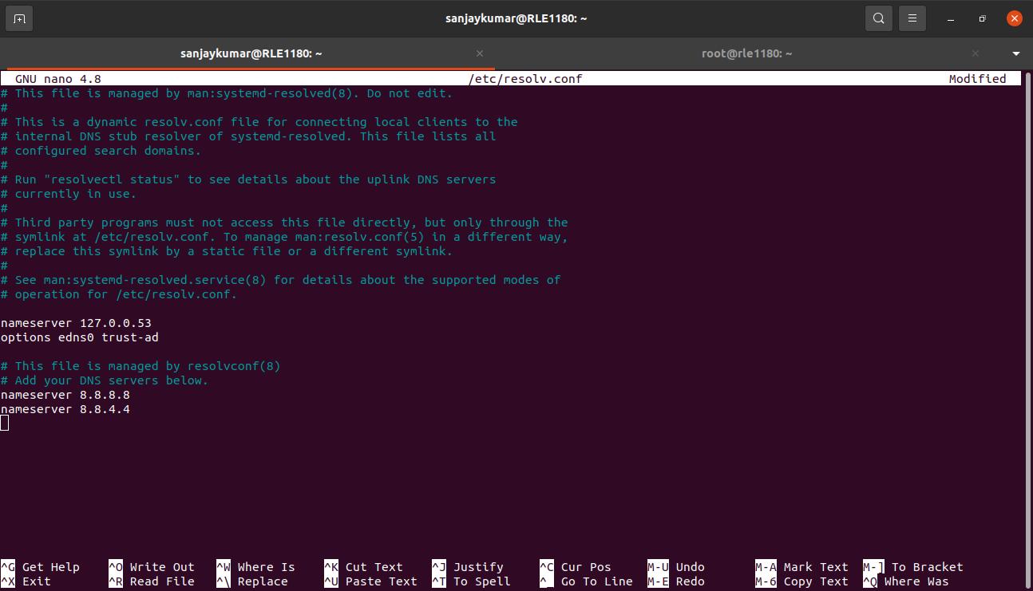
3.2. Test DNS resolution by pinging domain names :

ping google.com
You should see a series of responses showing that the domain name is being resolved to an IP address and the ping is successful.

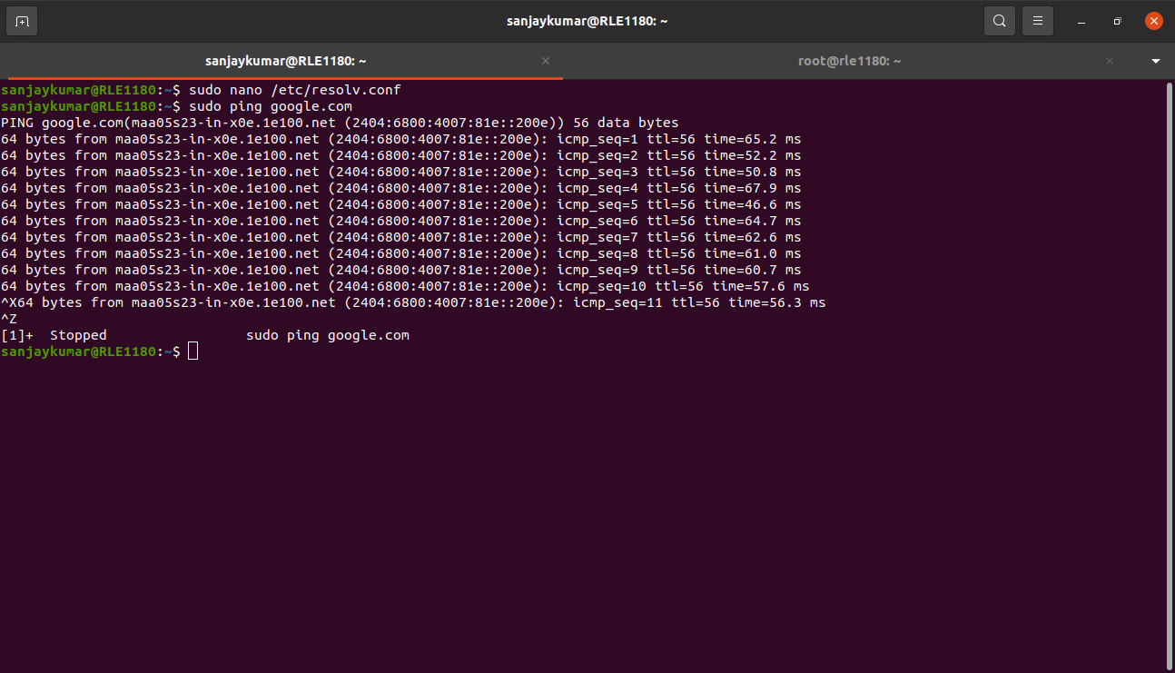
**Task 4: Firewall Configuration**
4.1. Configure a basic firewall with ufw
- Install the ‘ufw’ by using the following command :
sudo apt update
sudo apt install ufw
- enable the ufw service :
sudo ufw enable
- Allow SSH access (port 22) to your machine :
sudo ufw allow OpenSSH
This allows incoming SSH connections,which are essential for remote access.
- Deny all other incoming connections by setting the default incoming policy to “deny” :
sudo ufw default deny incoming
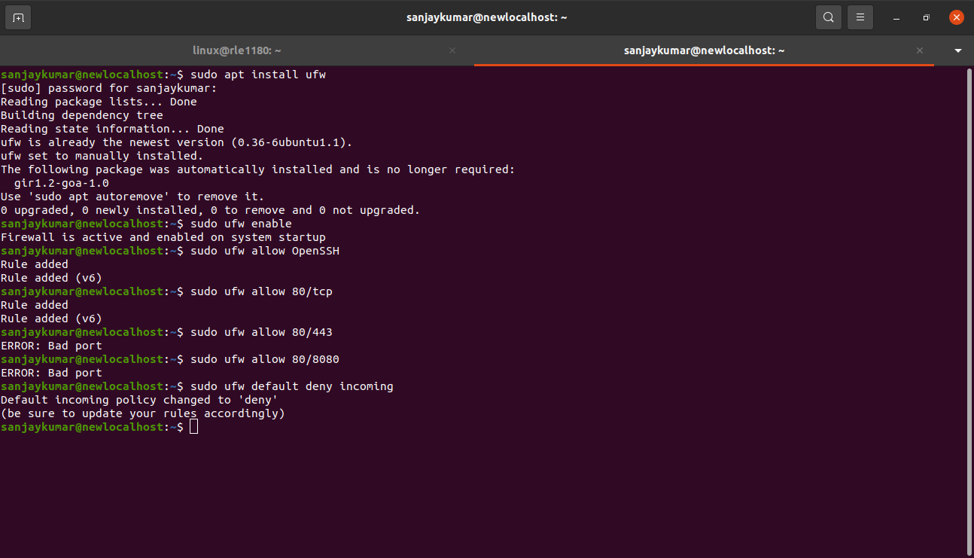

4.2. Enable the firewall rules and test the configuration :

- After configuring the firewall rules,you can enable them:
sudo ufw enable
- to verify the rules,you can check the status of ufw :
sudo ufw status
it should display a list of rules,including SSH and HTTP access.
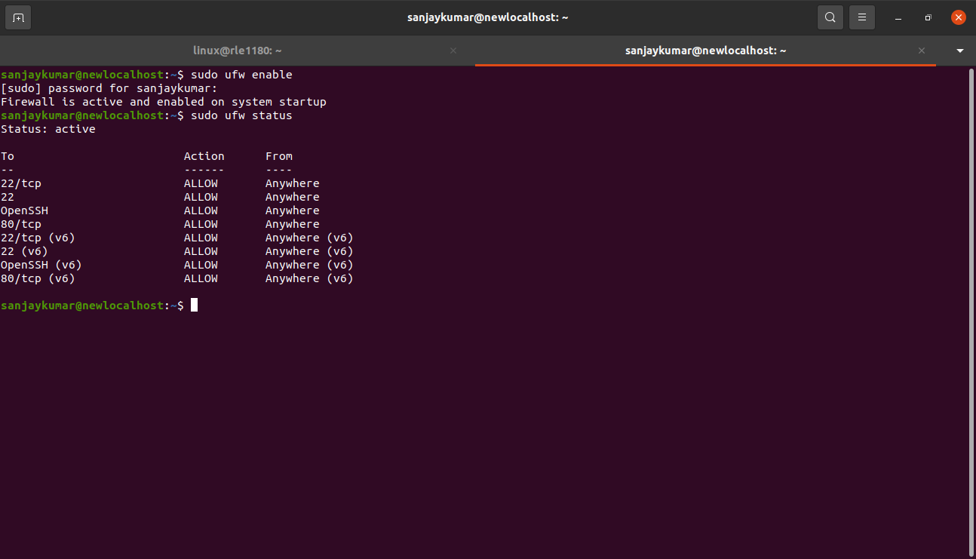
- Test the configuration by attempting to SSH into your system.
Ssh username@<your_server_ip>
ex : sudo ssh linux@192.168.122.93
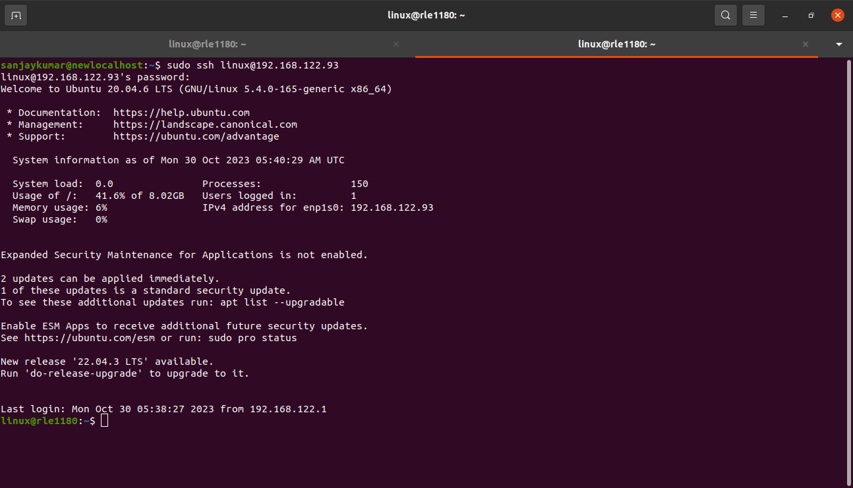
**Task 5: Network Troubleshooting**

5.1. Simulate a network issue :

You can simulate a network issue by disconnecting your network cable or disabling your network interface,depending on your specific situation.

- To disable your network interface,you can use the following command :
sudo ifconfig wlp5s0 down
This will effectively disable the network interface.

5.2. Diagnose the issue and attempt to reconnect.

- Check the status of your network interfaces using ‘ifconfig’ or ‘ip’ :
ifconfig
or
ip link
This will show you the status of your network interfaces,including whether they are up or down.
- Use ‘ping’ to check if your system can reach other devices on the network
ping 8.8.8.8 (# google’s DNS server)
If you receive responses,your system can still reach these devices. If you don’t get responses,it suggests a connectivity issue.

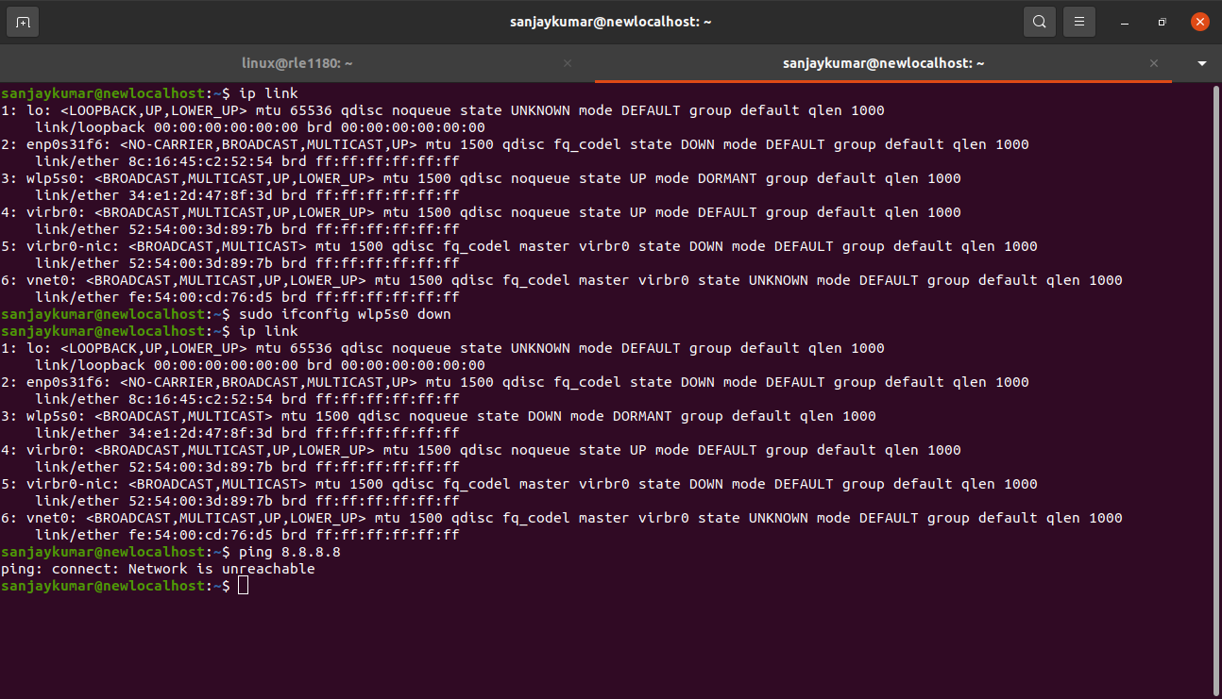

- If your network interface was disabled,re-enable it using the following command :
sudo ifconfig wlp5s0 up
- After re-enabling the network interface, use ‘ifconfig’ or ‘ip’ again to confirm that the interface is up.
- Use ping to test connectivity again.
Ping 8.8.8.8
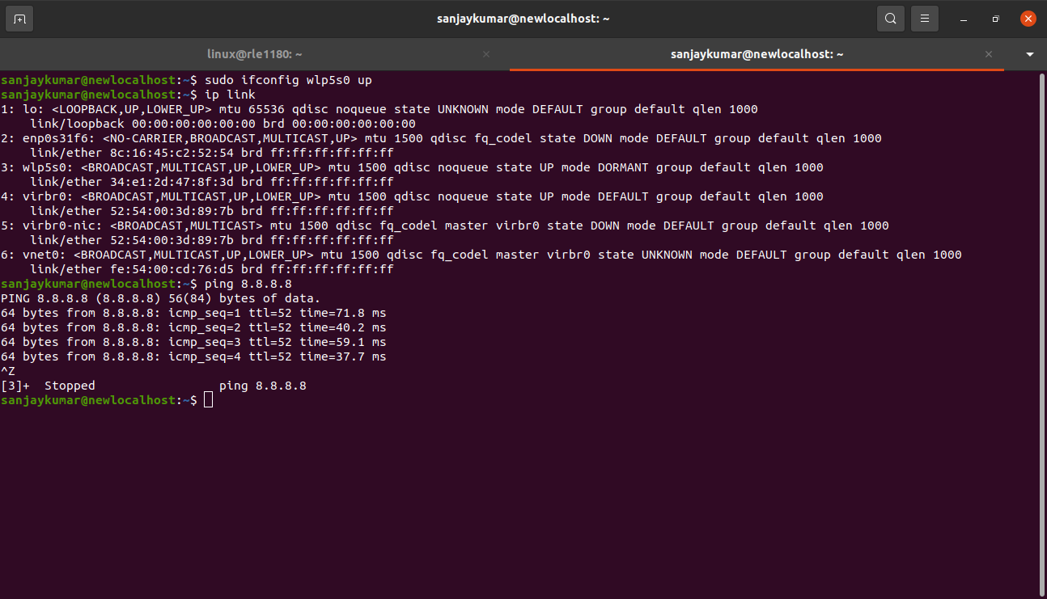
**Task 6: Network Monitoring**

To monitor network traffic in real-time and observe the bandwidth usage of different processes, you can use network monitoring tools like ‘iftop’ or ‘nload’.

6.1. install and configure a network monitoring tool :

- install iftop command :
sudo apt update
sudo apt install iftop
- start iftop by running the following command :
sudo iftop

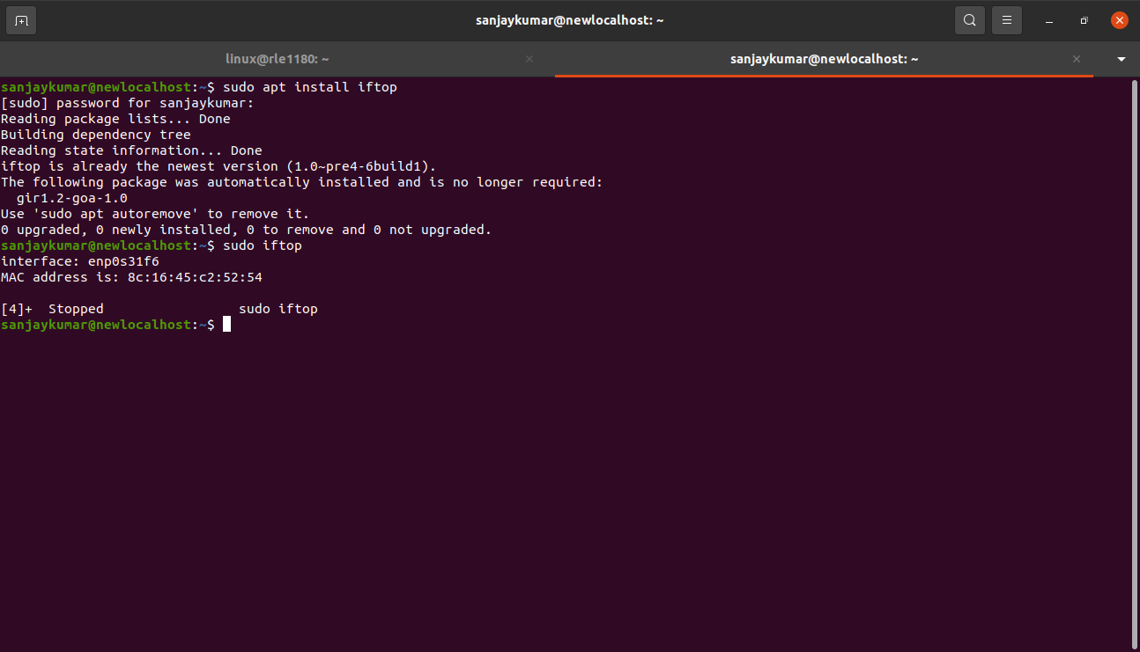
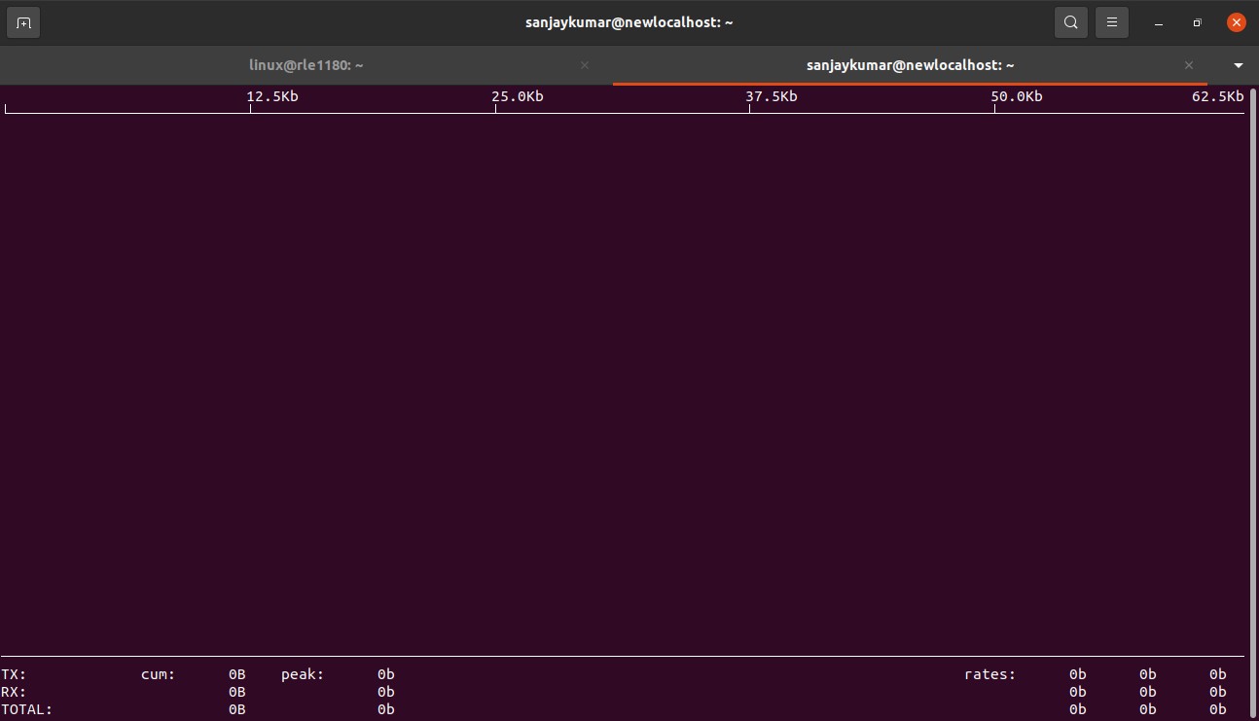
6.2. Monitor network traffic and observer bandwidth usgae :

using iftop :

- when you run ‘iftop’ command , you’ll see a screen that displays a list of network connections and their respective bandwidth usgae.
- It provides information about the source and destination IP addresses,port numbers, and transfer rates.

